Instruction Manual

----- CSF JET Multi Megasonic Generator -----
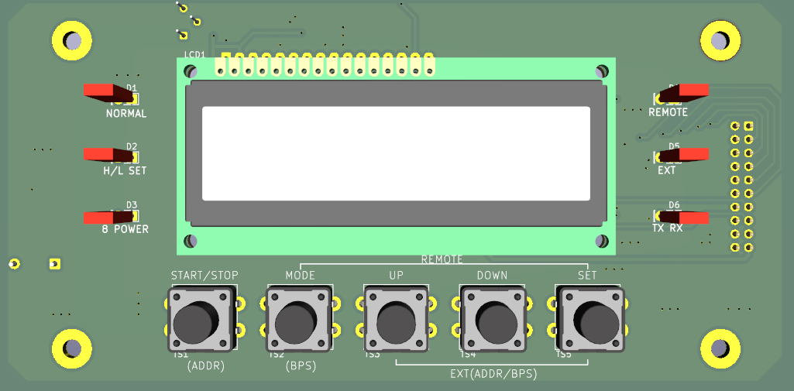

Generator : 1 EA Transducer : 1 EA

Thank you for purchasing this product.
This product is a generator to provide high-frequency electricity to PZT device attached to SF Nozzle for cleaning semiconductor wafer.
Make sure to understand this Instruction Manual before using this product to use appropriately. In case of problem appearance during installation or use, please contact our company to take appropriate measures immediately.
Thank you.
< OPERATING SUMMARY>

MODE | STATE | MENU KEY | FUNCTION
RUN MODE | NORMAL | -POWER ON  -MODE+UP/DOWN+SET | - START/STOP  - REMOTE ON  - 8 POWER ON  - RS-485 Monitoring  - Change Channel
 | REMOTE | -POWER ON  -MODE+UP/DOWN+SET | - REMOTE ON  - 8 POWER ON  - RS-485 Monitoring
 | EXT | -POWER ON  -MODE+UP/DOWN+SET | - REMOTE ON  - 8 POWER ON  - RS-422 Monitoring/Write  - Address Setting
SET MODE | H/L SET | MODE button  (H/L SET LED ON) | - High/Low Alarm Setting
 | 8 POWER | MODE button  (8 POWER LED ON) | - 8 POWER Setting
 | Frequency CH set | Press FREQ button for 5 seconds. Then SET button to select the channel you want to save. | - Only NORMAL MODE  Select the channel you want to save
* Error Reset → MODE+DOWN button
- When pressing buttons simultaneously, you should press about 2 seconds.
- When pressing FREQ button shortly, it displays currently set frequency for about 5 seconds.

Specification

NO. | Item | Specification
1 | Model Name | HS AUP Multi Megasonic Generator
2 | Max. Output | 1 Wmax
3 | Operating Frequency | 10 ch ( 285 kHz ~ 1180 kHz)
4 | Oscillation Type | Oscillation frequency fixed type
5 | Output Setting Range | 0.20W~1.00W (variable for each 0.01W)
6 | Output Adjustment  Method | Input button key input or RS-422 communication
7 | Interface | Communication Line : 9-pin D-SUB  Control Line : 25-pin D-SUB
8 | Using Environment | Temperature 18~35℃ Humidity 10~85%
9 | Power | AC 210 V ± 10 % 0.5 A 50/60 Hz  FUSE : 2A
10 | Sub-Function | - REMOTE Circuit  - 8 Step external output control Available to set 8 types  - External interface --------------- RS-422  - Various failure alarm  - Top/Bottom failure terminal HIGH, GO, LOW  - Oscillator failure TRANSDUCER ERROR  - Integrated alarm terminal OPERATE OUT  - Forcibly stopping terminal Stop oscillation when OPEN
11 | External Size of  Oscillator | 210(W) × 315(L) × 95(H)mm
12 | Weight of Oscillator | About 3 kg

- Product Composition
  - HS AUP Multi Megasonic Generator 1ea
  - High-frequency connection line 1ea (BNC connection line 7m)
  - 25p D-SUB connector 1ea (5m)

Caution on Product Use

Caution on Installation
<Generator>
①. Install after adjusting the level of the safe support which has no effect from vibration of generator.
②. Do not install the generator to the place with acid or alkali elements in the air. This may corrode the internal parts or destroy insulation, and cause shortage of its life span or
troubles.
③. Install the generator 5cm or more apart from a wall or other products. Also, do not install to the place with surrounding temperature of 40 ℃ or more.
④. Install the generator to the place where its heat could be released outside and circulate the air in front/back of it for ventilation.
⑤. Make sure to connect the assigned nozzle and the connection line should be connected in
the number order. When delivering the nozzle connection line, the line included should be used. When the line type or length changes, the oscillator or nozzle could be damaged.
⑥. Do not stag the generators and use by making a stacking shelves for generators. Also,
each level of shelves must be open in front, back, left and right to put generators to have smooth air circulation.
⑦. While handling the generator, make sure to pull out the power plug.
⑧. Especially, make sure to use it by supplying the power with appropriate current. (Appropriate voltage 190 ~ 220 V)

Caution on Use
①. In case of REMOTE operation, make sure to have an interval of 3 seconds or longer between [ON] and [OFF].
(If an interval is 3 seconds or shorter, this may lead not to reach to the setting value.)
②. It oscillates when REMOTE terminal is short. (Stops oscillation when opens.)
<Caution>
In case of operating switch of 2 or more oscillators at once, make sure to use the independent contact point (4 - COM). When operating 2 oscillators in parallel with equivalent contact point, this may lead to malfunction or failure of the oscillator.
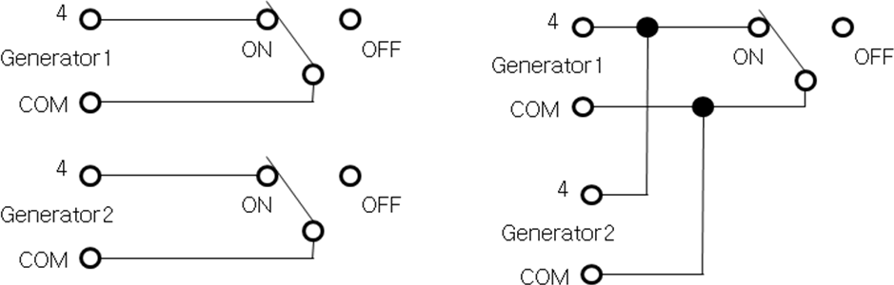
(Correct Wiring)
(Wrong Wiring)

③. Make sure to use the correct connector for the D-Sub connector at the back of the oscillator.
If D-Sub connector is not connected, the forcible stop terminal is OPEN and becomes stop condition of "Er7".
④. Please be careful during the use as the company is not responsible in case of damage or failure of the cleaned goods which used this product.

Name and Function of Each Part
This product consists of oscillator and vibrator nozzle.

Operation Panel
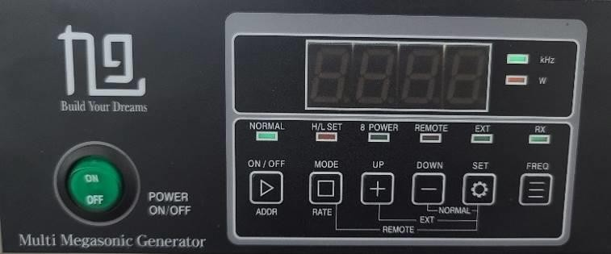
① Power Switch ② Operation Part

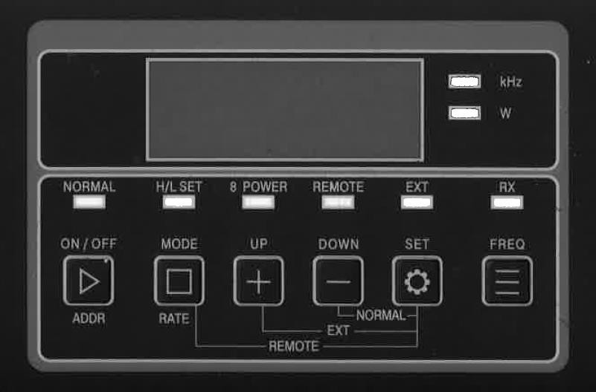
⑮
➃
⑤
⑥
⑦
③
○17
○16
⑧

⑨ ⑩ ⑪ ⑫ ⑬ ⑭

①. Power Switch
When pressing the switch, the condition maintains to flow electricity and the switch lights green.
②. Operation Part
The part to control operations of Megasonic.
③. Digital Display
Displays current output, setting output, various alarms and others.
④. NORMAL Mode Display Lamp
Available to set output (available to set from 0.20 ~ 1.00). Available to operate START/STOP(ADDR) switch.
⑤. H/L SET Display Lamp Set highest/lowest output
Set the highest value ( 0.25 ≤ set point + 0.05 ≤ 1.50 ) Set the lowest value ( 0.15 ≤ set point + 0.05 ≤ 0.95 )
⑥. 8 POWER Display Lamp
Set 8 types of output setting and highest/lowest output setting
Available to set the setting output and highest/lowest value setting done with NORMAL MODE and H/L SET MODE to Step 0, and set remaining Steps 1 ~ 7.
⑦. REMOTE Display Lamp
Displays REMOTE operation condition.
Flickering condition displays the ultrasonic oscillation status.
⑧. EXT Display Lamp
Uses to control and monitor the oscillator with RS-422 communication, and available to have REMOTE operation. Also, sets address of the oscillator.
BPS is 9600.
⑨. START/STOP Button
Oscillation starts when pressed, and stops when pressed again. From EXT mode, used to set address as ADDR button.

⑩. MODE (bps, Rate) Button
Button to change mode. When pressed once, mode changes as [NORMAL] [H/L SET] [8 POWER] [NORMAL] …….
⑪. UP Button
Button used to control values of [Output Setting] [Highest/Lowest Setting] from each mode. Count increasing [1] or [0.01] when pressing the button once.
⑫. DOWN Button
Button used to control values of [Output Setting] [Highest/Lowest Setting] from each mode. Count decreasing [1] or [0.01] when pressing the button once.
⑬. SET Button
Button used to set [Output Setting] [Highest/Lowest Setting] from each mode.
⑭. FREQ Button
When pressed shortly, it displays currently set frequency for about 5 seconds.
When pressed about 5 seconds from Normal mode, available to change to desirable frequency channel as changing to FREQ SET mode. Press UP/DOWN button to select desirable frequency channel, and when pressing SET, channel changes and saves.
⑮. RX Display Lamp
Flickers when the oscillator receives DATA from RS-422 communication mode of EXT. Lamp lights on when RS-422 communication is wrong connected, and lights off when connected.

○16 . W Display Lamp

Displays the displaying value from the digital display when START. Lights off only when displaying frequency.

○17 . kHz Display Lamp

When pressing FREQ button shortly, it lights on and displays that the displaying value on the digital display is the frequency. When change FREQ SET mode by pressing FREQ button about 5 seconds from Normal mode, the light turns off.

Back of Oscillator
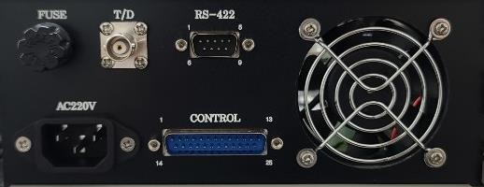
② ③ ⑤

① ④
①. Power Connector
Connector to connect sub-power cords.
②. Fuse Holder
Holder to insert fuse.
③. Output Connector
Connector to connect SF nozzle. Make sure to connect the assigned nozzle and the connection line should be connected in the number order. When delivering the nozzle connection line, the line included should be used. When the line type or length changes, the oscillator or nozzle could be damaged.
④. Control Connector
D-SUB 25-pin connector. Connecting line which implements various sub-functions.
.
⑤. D-SUB 9-pin connector
Connector for RS-422 communication.

Connecting Method

Connect oscillator and nozzle
Connect the output connector and the nozzle line at the back of the oscillator. Make sure to connect with the match of the number which combined during the release.
When number or line is changed, this may cause failure.

(2) Connecting power cord
3
1
2
Pin 1 AC210V
Pin 2
Pin3 Earth

Connect the power cord supplied during the delivery to the connector.

Connect 25P D-SUB connector
① Use included D-SUB connector for oscillator.
When disconnecting the connector, the status become non-oscillation with forcibly input
condition. (Er7)

Connect RS-422
Wired with D-SUB 9-pin connector as 1: Tx+, 2: Tx-, 3: Rx+, 4:Rx-.

Operation ready
① First of all, supply deionized water to the nozzle.
② Turn on the power switch and press ON switch.

Operating Method
① When pressing the power switch (POWER ON/OFF) of the operation panel, it becomes [ON].
② The green lamp of [NORMAL] of mode display turns on, and the digital display displays [0.00] in flickering (LED blinks).

NORMAL
lights

(1). In case of NORMAL mode cleansing
. Cleansing starts when pressing START/STOP button (oscillation starts).
. Digital display displays currently operating output (detected output) and starts oscillation
. (In case of stopping, press START/STOP button once again.)
. If you wish to change the output, change the digital display with UP or DOWN button (UP/DOWN function is available even in oscillation stop or operation)
. If you wish to set (memorize) output after displaying desirable output, press SET button.
. Set output memorizes until reset while power is [OFF].
. Monitoring is available with RS-422. (Unavailable to write)
- In case of setting highest/lowest (H/L SET mode) of output

. Press START/STOP button to stop oscillation.
. Press MODE button and change to H/L SET mode.
. 7-SEGMENT lights to display [0.00].


H/L SET
lights

(Set highest value)

. When pressing UP button, it temporarily display Hi and display the currently set highest value by flickering.
Hi ⇒ “0.80”
. Use UP button and DOWN button to set desirable highest value.
. Press SET button to set (memorize).
. The highest set value lights on.

(Set lowest value)
. When pressing DOWN button, it temporarily display Lo and display the currently set lowest value by flickering.
Li ⇒ “0.20”
. Use UP button and DOWN button to set desirable lowest value.
. Press SET button to set (memorize).
. The lowest set value lights on.
. After completing SET, press MODE button to return to NORMAL.
# Caution ;
. From H/L SET mode, nothing is available but setting the highest/lowest output value.
. The highest/lowest output value range is available to set within the following range.

0.25 ≤ output set value +0.05 ≤ highest output value ≤ 1.50
0.15 ≤ lowest output value ≤ output set value -0.05 ≤ 0.95

. In case of setting highest or lowest set value, press MODE button to move to NORMAL mode after SET completion.

In case of changing frequency channel (Freq SET)
. Press FREQ button for 5 seconds.

kHz flickers
(Set frequency channel)
. Current frequency channel value is displayed in flickering.
. Use UP or DOWN button to set desirable frequency channel.
. Press SET button to set (memorize).

☞ Available to change frequency channel from EXT mode during ultrasonic oscillation. When frequency change command is received, stops oscillation for 1 second, and
oscillates again after setting to changed frequency.

In case of 8 type output setting (8 POWER mode)
. Press START/STOP button to stop oscillation.
. Press MODE button to move to 8 POWER mode.
. 7-segment LED flickers 1.

8 POWER
lights
(Output Setting)
. Press SET switch.
. 7-seg LED flickers current setting value.
. Press UP and DOWN switches to set the desirable output.
. Press SET button to set (memorize).
. 7-seg LED lights 1. (Set highest output)
. Press UP switch.
. 7-seg LED displays 1Hi, and then flickers current highest output value.

1Hi 1.50
. Press UP and DOWN switches to set the desirable highest output value.
. Press SET button to set (memorize).
. 7-seg LED lights 1. (Set lowest output)
. Press DOWN switch.
. 7-seg LED displays 1Lo, and then flickers current highest output value.

1Lo 0.05

. Press UP and DOWN switches to set the desirable highest output value.
. Press SET button to set (memorize).

. 7-seg LED lights 1.
(Step 2 output setting method)

. Press START/STOP switch.
. 7-seg LED lights 2.

. Set output value, highest/lowest value with the equivalent method of Step 1.
. After setting completion, press START/STOP switch to set Step 3 output.

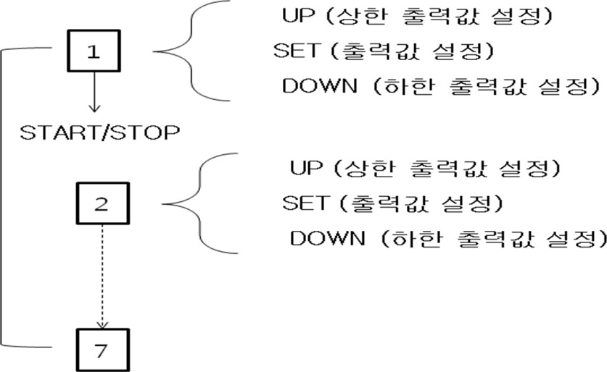
Setting Order Block Diagram

AUTO Calibration
. In case of connecting Generator by changing the nozzle, this function should be implemented, and it is a function to automatically set the output provided from Generator to nozzle by each channel with 0.5W.

<Operating Method> Turn OFF the power.
Press <UP>, <DOWN>. <SET> keys at once, and turn ON the power. Calibration starts by automatically changing the channels.
When automatic setting completes, buzzer alarms. Turn OFF and ON the power again to complete setting.

How to change individual frequency input to each CH
* Caution: If possible, user shall not use the function as the change of frequency input to channel influences closely to output matching, if necessary, please implement after discussing with the manufacturer.

<Operating Method>

Press Mode key 3 times from NORMAL mode and move to password input screen.


From the display screen, input password. (password:0001)
Input '0' from the first digit with UP/DOWN key and press SET key. When display blinks from the next digit, set '0' with UP/DOWN key and press SET. Continuously, set '0' and '1' on the remaining digit and press SET.
Then, press UP/DOWN key to select number of the desirable channel, and press SET. Again, press UP/DOWN key to select desirable frequency and press SET to complete frequency setting.
Finally, press MODE key to complete setting.
When frequency setting completes, turn OFF the power and turn ON again.

In case of using REMOTE mode
This mode is used to have Step 8 external output control and oscillate as REMOTE terminal. From this mode, START/STOP button and frequency channel change are unavailable, and stability is improved. Monitoring is available with RS-422. (Unavailable to write)
. Press START/STOP button to stop oscillation.
. Press the power switch of the operation panel to turn OFF the power.
. Please wire the control line for external control.
. After connection, press both SET button and MODE button and turn ON the power.
. 7-seg LED lights and display [0.00].


REMOTE
lights

In case of using external control (EXT mode)
This mode puts output monitoring to RS-422, and oscillation ON/OFF is used to control with RS-422 and REMOTE.
. Press the power switch of the operation panel to block the power.
. Please wire the control line for external control.
. After connection, press both SET button and UP button and turn ON the power.
. 7-seg LED lights [0.00].


EXT
lights

(Register oscillator address)

. Press ADDR (START/STOP) button.
. 7-seg LED lights and displays currently set ADDR (initial value 0).

. Set the oscillator address with UP or DOWN button. (Available to set No.0 ~ 14)
. Press SET button to set (memorize).

# Transfer speed BPS is unavailable to change as fixed as 9600.

# Caution
For the address setting returns to EXT initial mode automatically after few seconds when UP or DOWN button is not pressed while setting the current value.

# In case of changing to normal mode (NORMAL mode)
. Stops oscillation.
. Press the power switch of the operation panel to block the power.
. After connection, press both SET button and DOWN button together and turn ON the power.
. LED of [NORMAL] lights on.
# When changing setting value, H/L SET, 8-POPWER value, EXT mode should be implemented after changing to RS-422 communication or NORMAL mode.

Cable Wiring Diagram
- SENSOR <Back Panel> D-SUB Connector (25 PIN)

 | NO. |  |  |  |  | CONTENT |  | RELAY
25 |  |  |  | Red |  | SENSOR |  | SHORT ( normal )
13 |  |  |  | Yellow
SHIELD |  |  |  |  |  |  | Shield to 25P connector body

- REMOTE <Back Panel> D-SUB Connector (25 PIN)

 | NO. |  |  |  |  | CONTENT |  | RELAY
9 |  |  |  | Yellow |  | ON when SHORT |  | REMOTE
22 |  |  |  | Red
SHELD |  |  |  |  |  |  | Shield to 25P connector body

- ALARM <Back Panel> D-SUB Connector (25 PIN)

NO. |  | CONTENT |  |  | RELAY
1, 7 | Black | COM
14 | Yellow |  | LOW ALARM (ER1) |  | SHORT ( at Alarm )
20 | Red |  | OPERATE OUT (integrated  alarm) |  | OPEN ( at Alarm )

Shield to 25P connector body
SHIELD
<Display 25P back panel detail> D-SUB Connector (25 PIN)

NO. | CONTENT | RELAY |  |  | Wire Color
1 | LOW ALARM  (Err1) | SHORT (at Alarm) |  |  | Black
14 |  |  |  |  | Yellow
2 | GO | SHORT (normal)
15
3 | HIGH ALARM  (Err2) | SHORT (at Alarm)
16
4 | BLANK
17
5 | BLANK
18
6 | TRANSDUCER ALARM  (Err5) | SHORT (at Alarm)
19
7 | OPERATE OUT  (TOTAL ALARM) | OPEN (at Alarm) |  |  | Black
20 |  |  |  |  | Red
8 | BLANK
21
9 | COM |  |  |  | Yellow
 |  |  | REMOTE
22 | 4 |  |  |  | Red
10 | 3
23 | 2
11 | 1
24 | BLANK
12
25 | SONIC LOCK INPUT  (Err7) | SHORT (normal) |  |  | Red
13 |  |  |  |  | Yellow

① Output level management
Available to manage ultrasonic output level condition from outside.
  - When operating output level within highest/lowest setting value range [GO] terminal becomes short (SHORT contact point) condition.
  - In case of remaining output level for 5 seconds with the highest setting level value or higher
Digital display screen displays "Err2" and the oscillator stops automatically. [HIGH] terminal becomes short (SHORT) condition.
  - In case of remaining output level for 5 seconds with the lowest setting level value or lower
Digital display screen displays "Err1" and the oscillator stops automatically. [LOW] terminal becomes short (SHORT) condition.
* Each terminal is the contact point of output relay (contact point capacity AC PEAK 100V, DC100V,0.3A). When turning OFF the power, terminals are all OPEN.

② Nozzle error warning
In case of incorrect vibrator connection or error appeared such as nozzle failure Warning output (SHORT contact point output) appears.
In case of nozzle overload error remains 5 seconds or longer, the digital display displays "Err5" and the oscillator stops automatically.
[TRANSDUCER ALARM] terminal becomes short (SHORT) condition.

③ Integrated alarm terminal
In case of appearance of abovementioned error (output level, oscillator error) or if power supply is not made, [OPERATE] terminal becomes open (OPEN).
Please use 24V, 0.1A or more for the switch contact point capacity.

④ REMOTE terminal
Used to operate [ON] [OFF] when using when generator and vibrator (or vibration plate, cleansing bath) are far apart.
Oscillates in accordance of short condition between POWER CONTROL terminal (4-COM).
REMOTE LED of operation panel lights on.

* Caution: Please have an interval of 3 seconds or longer between [ON] [OFF] operation.
: In case of using by operating 2 or more oscillators and equivalent switch, use the independent contact point. In case of connecting to the equivalent contact point in parallel, the oscillator may have malfunctioning or failure.
Please wire the input terminal (4-COM) as follows.

(Correct Wiring) (Wrong Wiring)

⑤ Step 8 output select terminal
In case of setting ultrasonic output level to Step 8 to the operation panel, output is selected when each terminal of the POWER CONTROL is connected with BCD input as follows.

# BCD input table between POWER CONTROL terminals
 | 4 | 3 | 2 | 1 | Terminal No.
 | 0 | - | - | - | Oscillation stop
 | 1 | 0 | 0 | 0 | Outputs NORMAL setting value.
 | 1 | 0 | 0 | 1 | Outputs setting value 1.
 | 1 | 0 | 1 | 0 | Outputs setting value 2.
 | 1 | 0 | 1 | 1 | Outputs setting value 3.
 | 1 | 1 | 0 | 0 | Outputs setting value 4.
 | 1 | 1 | 0 | 1 | Outputs setting value 5.
 | 1 | 1 | 1 | 0 | Outputs setting value 6.
 | 1 | 1 | 1 | 1 | Outputs setting value 7.

REMOTE
terminal

"1" is COMM terminal and SHORT condition, and "0" displays OPEN.
⑥ Forcible stop input terminal (SENSOR)
- In case of this terminal opens during oscillation stop

Digital display screen displays "Err7" and the oscillator stops automatically.
- In case of this terminal opens during oscillation operation
Digital display screen displays "Err8" and the oscillator stops automatically.
# Before SHORT again, the oscillator does not operate even power is turned on again. In case of not using, you may SHORT.
Sometimes it is used for emergency stop or connecting with liquid detecting sensor. From the general product delivery, it is delivered by shorting within D-SUB 25P.

ERROR Display
ERROR displayed from the operation panel means the next.

ERROR Code | Contents | Oscillation  condition
Err1 | Output is lower than the lowest setting value. | Stop
Err2 | Output is higher than the highest setting value. | Stop
Err5 | Error in vibrator overload. | Stop
Err6 | In case of setting unavailable setting. | Oscillation  continue
Err7 | forcible stop input terminal is in OPEN condition. | Stop
<Measures in appearance of alarm>

AL | Contents | Cause | Check and Measures
Err1 | LOW ALARM | - When POWER value is less than  LOW ALARM value  - Oscillator failure | - Set LOW ALARM value smaller than POWER value ( 0.20W ≤ LOW ALARM ≤ 0.40W )  - If Err1 appears after changing LOW ALARM value,  request for A/S
Err2 | HI ALARM | - When POWER value is bigger than HI ALARM  - Oscillator failure | - Set HI ALARM value bigger than POWER value ( 0.60W ≤ HI ALARM ≤ 1.50W )  - If Err2 appears after changing HI ALA value, request for A/S
Err5 | TRANSD UCER ALARM | - Oscillator line connection faulty  - Oscillator line disconnection  - Oscillator failure | - Check oscillator  - Request A/S  - Request A/S

Err7 | Sonic OFF SENSOR ALARM | - Oscillator control connector connection faulty  Red, yellow lines of SENSOR cable of oscillator control connector OPEN  Red and yellow lines OPEN | - Check oscillator control connector  - Red, yellow lines of SENSOR cable of oscillator control connector OPEN  Red and yellow lines SHORT
# Caution: After Err appearance, press "MODE + DOWN" for the immediate release. (For Err7 releases when power is turned ON again after turning OFF)
After turning OFF the power, Err returns to release condition even power is turned ON again.
* In case of oscillation stop after displaying Err1, 2, turn on and off the power switch once, or
reset output value or highest/lowest setting value after Err release.
But, if ERROR appears again, the oscillator is in failure.

Communication Specification

RS-422 Specification

Electrical Features | Follows EIA RS-422
Communication Method | Half duplex
Synchronization | Asynchronous
Transfer Speed | Fix to 9600 bps
Start Bit | 1 bit
Data Length | 7 bit
Parity | Even Parity
Stop Bit | 1 bit
Delimiter | CR
Text Code | ASCII Code
Address (ID) | 0 ~ E
ERROR Check | BCC (even horizontal  parity)
Frequency channel | 0 ~ 9

- Communication Command and Response

Communicati  on Command | Transmission Command | Response
Output Electricity Setting  W Command | “I[ID],W[electricity 3 digits]W,[BCCH],[BCCL],[CR]”  * Set electricity in range of 000 ~ 100 (000=0.00W/070=0.70W)  Available from EXT(422) Mode | “I[ID],W[electricity 3 digits]W,[BCCH],[BCCL],[CR]”
Read status STA Command | “I[ID],STA,[BCCH],[BCCL],[CR]”  * Available from every mode | “I[ID],M[measurement electricity 3 digits]W,Rx,Ex,Sx,Wx,Fx,Vx,Axxx,Oxxx[BCCH],[BCCL  ],[CR]  Rx-REMOTE condition x=0 Open, =1 Short  Ex-Mode condition x=0 normal, =1 EXT Mode (422) Sx-SENSOR condition x=0 Open =1 Short  Wx-Output Control condition x=0 Electricity Normal  x=1 Highest alarm x=2 Lowest alarm  Fx-Frequency channel (ch No) condition x=0~9  Vx-Voltage (0~9V) Display actual votage as 9 steps Axxx-Current (0~999mA )  Oxxx-Impedance (50~999Ω)
Soft version command | “I[ID],VER,[BCCH],[BCCL],[CR]” | “I[ID],VERxxxx,[BCCH],[BCCL],[CR]”  Xxxx is version e.g.1.00
Ch No Setting C Command | “I[ID],C[ch No,2 digits]C,  [BCCH],[BCCL],[CR]”  * Set channel in range of 00 ~ 09 (00=ch No.0/09=ch No.9)  Only available from EXT mode (422) | “I[ID],C[ch No 2 digits]c,[BCCH],[BCCL],[CR]”
[ID] --- 0~E set device address
[BCCH] --- 0~F (good horizontal parity top 4 bit) [BCCL] --- 0~F (good horizontal parity bottom 4 bit) [CR] --- 0D (16 decimal)
  - Transmission command response is delayed 600mS right after REMOTE short.
  - During ultrasonic oscillation, output setting response delays about 1 second at the most.
  - In case of changing Ch No setting, oscillation is stopped for 1 second to change setting frequency.

ERROR Response
① When ERROR appears after [CR], ERROR response is released. ex) “[ID],COMERR,[BCCH],[BCCL],[CR]”
If setting value is outside the regulation, NUMERR is released (only output setting command W, C)
<ERROR Response Details>

ERROR Command (#2) | Contents | Priority when error appears
PARERR | Parity Error | 1
FRMERR | Fleming Error | 2
OVRERR | Over Run Error | 3
COMERR | Command Error | 4
NUMERR | Value Error | 5
BCCERR | BCC Error | 6

- If command error and setting electricity is outside the regulation, it maintains condition before input.
- If ID of communication and oscillator sides are not matching, it does not response.

Examples of transmission and response
① Example of output electricity setting : ID=1, If output electricity is 0.1W Transmission Command Response
“I1,W010W,4,9,[CR]” ⇒ “I1,W010W,4,9,[CR]”
② Example of frequency setting : In case of ID=1, ch No 1
Transmission Command Response
“I1,C01C,7,9,[CR]” ⇒ “I1,C01C,7,9,[CR]”
③ Example of condition reading ID=1, If output electricity is 0.1W, second No=2 Transmission Command Response
“I1,STA,3,E,[CR] ⇒ “I1,M010W,R1,E1,S1,W0,F2,V1,A020,O232,1,9,[CR]”

A/S
- Warranty Period
Free warranty is available within 18 months from the date of purchase or 2000 hours based on the product operation time.
But, consumables including fuse and packing are separate.

* Exceptional clause for warranty
- Failure caused by careless handling
- Failure caused by careless management or moving after installation
- In case of repair or partial modification of product outside the company
- Failure caused by fire, earthquake, flood or other natural disasters

- Warranty Range

- This warranty only valid in Korea.
But, in case of use in overseas, the repair is available with equivalent condition in Korea if this product is requested for repair by taking into Korea.
Also, separate mutual discussion is required for the overseas using products.
<Initial Setting Value>

MODE |  | EXT MODE
ADDRESS |  | 1
CHANNEL |  | CH 0
TRANSFER RATE |  | 9600 bps (Fix)
POWER |  | 0.50 W
LOW ALARM |  | 0.20 W
HI ALARM |  | 0.80 W
8 POWER | 1~7 POWER | 0.05 W

 | 1~7 HI ALARM | 1.50 W
 | 1~7 LOW ALARM | 0.00 W

